Beacon Ave Trail Improvements

Background
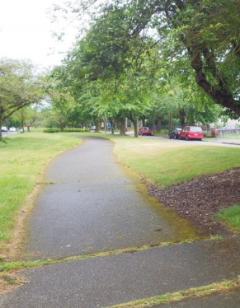
South of Jefferson Park, Beacon Avenue contains a wide median that contains a trail, benches, trees, parking and other vegetation. The path runs just under 4 miles from Columbian way to the end of Beacon Avenue headed south.
This trail is enjoyed today by many community members with people walking, running and biking down the trail. It contains a few amenities such as benches for people to sit down. Generally, it is not used by commuting cyclists, though, you do see adults and kids on recreational rides along the trail.

Opportunities for Improvements
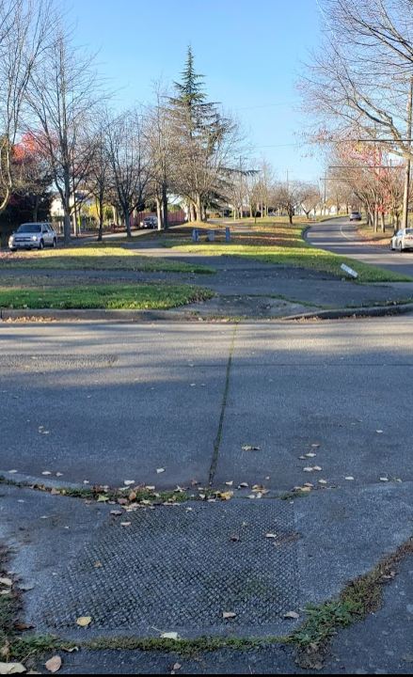
The Beacon Ave Trail could use improvements to increase utilization as well as improve amenities and safety throughout the length of the trail. With modest improvements we may see new users of the path as well as a better experience for current users of the path.
This trail contains quite a few crossings due to its location; since it runs on the median the trail ends up having a crossing nearly every block. At two major intersections there is no way to remain on the trail and people must cross three times via the sidewalk; at the minor intersections frequently, there is no marked crosswalk for the trail.
The trail also needs significant pavement maintenance; there are several potholes/sinkholes which pose a hazard to pedestrians and cyclists in addition to the frequent “rough” pavement damaged by nearby trees that pose tripping hazards and create bumpy rides.
The last opportunity we’ll touch on is path width. The path generally is wide enough for pedestrians and cyclists to share, however; there are several points where the path narrows significantly that expanding may help improve flow and comfort for trail users. In these narrower areas the path also tends to have significant damage that needs to be fixed.

Why now, why here? What the data tells us
Using available data from the City of Seattle’s open data tools as well as previous studies that are available we believe there is strong case for improvements to the Beacon Avenue Trail.
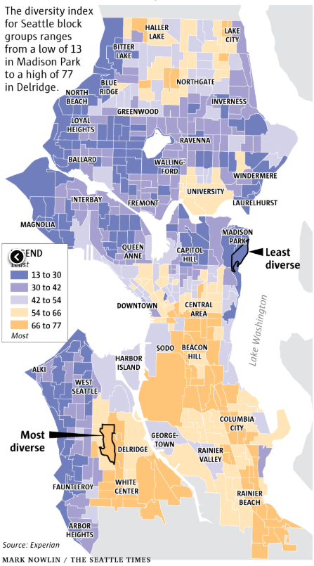
The available crash data along the corridor indicates that, outside of hundreds of vehicle crashes, there have been at least 15 seriously injured pedestrians and 6 people seriously injured while biking between Myrtle and Columbian. District 2 contains the most serious injury crashes of any district in Seattle and the whole of the Beacon Ave. Trail resides within this District.
The area the trail runs through is a traditionally underserved community that has lacked investment; there are many people who live here who have immigrated here from outside the United States and there is a large array of languages spoken in this area, more then any other part of Seattle. The area contains many tracts that are lower income then the Seattle average and it is one of the more racially diverse areas of the city.
Last, the City of Seattle recently completed a “Trails Upgrade Plan”. This plan largely echoes anecdotal evidence: the trail needs improved connectivity at intersections (particularly those that have no trail crossing) and improved crossing safety in order to better activate the trail. The plan proposes additional improvements to better connect this trail to other trails and to provide greater amenities for trail users.

Our Proposal
We have several ideas that we believe can improve the trail usage, safety, and comfort. We are unable to propose changes along the entire route due to cost limitations, however; we hope this becomes the first phase of improvements with more funded via other means in the future. We list additional improvement proposals under “Future Phases”. At the end of the document under “Project Map” you will find a map indicating where changes or repairs are needed. [Continued on the next page]

Raised Crosswalks between S Myrtle St & Columbian Way S:
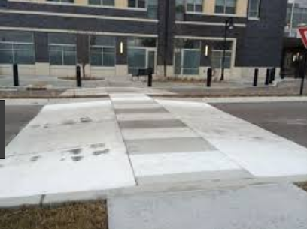
Between Myrtle and Columbian, we are proposing the implementation of raised crosswalks at 10 locations:
- 28th Ave S.
- 27th Ave S.
- Brighton St
- Holly St
- Warsaw St
- Eddy St
- Juneau St
- Orcas St
- Brandon St
- Dawson St
Raised Crosswalks provide for more comfortable and safer crossing for trail users by raising the crosswalk to be at the same level as the trail. Drivers of cars must drive up onto and over the crosswalk, like a speed hump. These treatments slow drivers down which improves outcomes in a crash as well as reduces the number of crashes.

Graham St Crossing
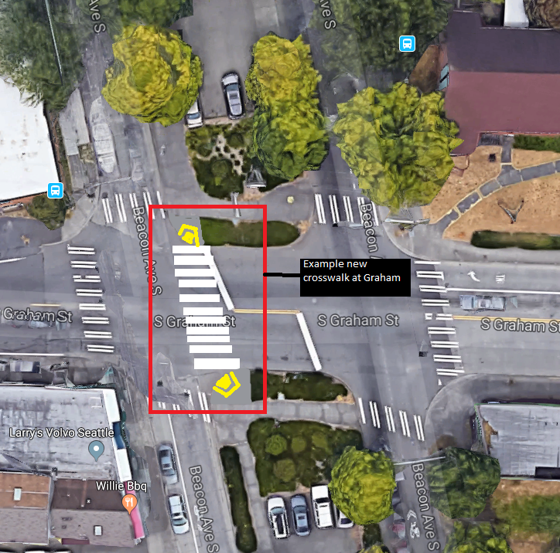
Currently there is no way to stay on the path at Graham St; the current configuration requires trail users to leave the path and cross three separate times to continue on the trail. This leads to commuter cyclists avoiding the path as the delay is significant and makes using the path much more difficult for slower trail users or users using mobility devices. Some pedestrians jaywalk, if able, to continue on the path.
We propose that at Graham Street a new crosswalk is created (along with curb ramps) that allow trail users to stay on the path. This may require signalization changes such as a leading pedestrian phase to ensure safe operation. In addition, the exact location may need refinement.

Trail Smoothing
The trail is located next to beautiful trees that provide shade and character to the median, however; due to neglect of maintenance on the trail there are places throughout the corridor that have rough patches which can pose tripping hazards as well as reduce comfort on the trail. Where possible the trail should be smoothed or repaired. We have noted locations on the “Project Map” (below).
It should be noted that along the street there are also sidewalks on both sides. The sidewalks have also suffered severe neglect and many areas have extreme uplifts that renders the sidewalk unpassable or difficult to use by people with assistive devices and poses trip hazards. For that reason, many more vulnerable walkers choose the Beacon Ave Trail as the damage to the trail is less severe as it was made from asphalt instead of concrete. Concrete portions of the path need significant repair.

Future Phases (as funding allows)
After completing this phase, or as funding allows, additional improvements are still needed along the trail in order to bring the trail to it’s maximum potential. We hope the above improvements reinvigorate community interest in helping bring future grants and funding to the Beacon Ave. Trail.

Additional Crossing Enhancements
Additional raised crosswalks should be provided South of Myrtle until the end of the trail; these additional improvements will make the path more desirable to use for more users and improve the safety of existing trail crossing
In addition to additional raised crosswalks, the major intersections at Myrtle and Columbian way will need significant work to build crossings through the intersection, similar to our proposed actions at Graham street above.

Trail Access Improvements
A notable concern is crossing the busy streets of Beacon Ave. to access the median and trail itself can be dangerous for pedestrians and difficult for cyclists who are generally in the roadway already. At high volume locations additional crossing improvements are needed and many pedestrians indicate that accessing the trail is surprisingly scary.
In addition, at the ends of the trail and at crossings of other Protected Bike Lanes (such as Columbian way or Myrtle) and other trails (such as the Chief Sealth Trail) access for bikes needs to be reviewed to ensure there is way for bikes of varying sizes to get onto the trail from the roadway or vice versa for bike users exiting the trail back to the roadway or onto another trail/protected bike lane.

Amenities
Many people use the trail for walking pets, exercise, or just recreation. The trail provides only minimal amenities, with several benches located sporadically along the trail. Trail users have indicated a desire for more benches and tables along the trail, particularly for older users of which there are many. Other users have noted there is 0 garbage bins along the path leading to pet waste and other little being thrown on the ground or users carrying trash for a large distance.
Some areas may also benefit from trail widening to ensure a pleasant experience for all users.

Lighting
In specific areas, and particularly during darker months, there is a need for pedestrian scale lighting if possible to improve visibility and safety for trail users. Some areas because of the dense nature of the trees are very dark and can be concerning for trail users.

Contact
Questions? Comments? Concerns? Contact info@bhsafestreets.org or visit www.bhsafestreets.org.

Project Map
